**DevOps Certification Training**

Lab Guide



This section will guide you to:

* Use labs to execute all demos included in this course

This lab has two subsections, namely:

* + 1. Starting practice labs on LMS
    2. Using different IDEs and software required for the DevOps certification training course

**Step 1:** Starting practice labs on LMS

* Login to Simplilearn LMS
* Go to the respective course

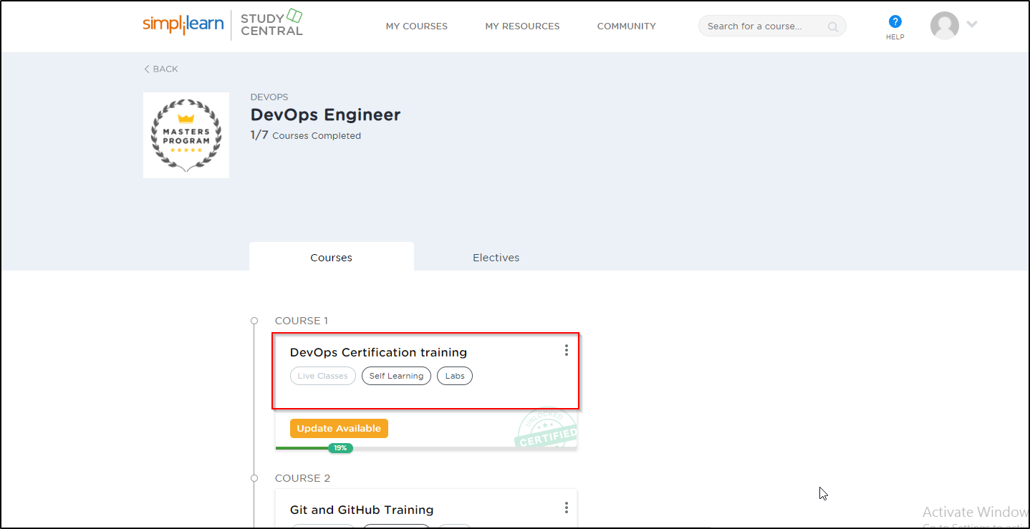

* On the left, you will find the course ToC page
* To its left, you will find the **PRACTICE LABS** tab
* Click on it

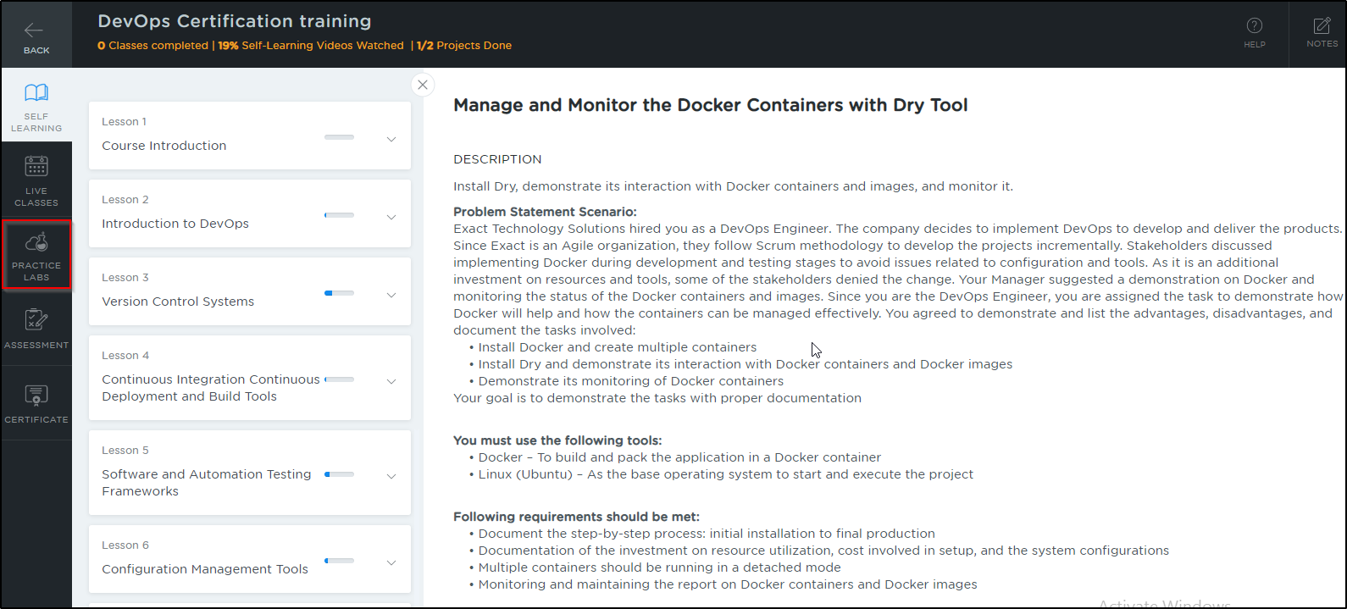

* As a new window opens, read the instructions and click on **LAUNCH LAB**
* This will launch practice labs for this course

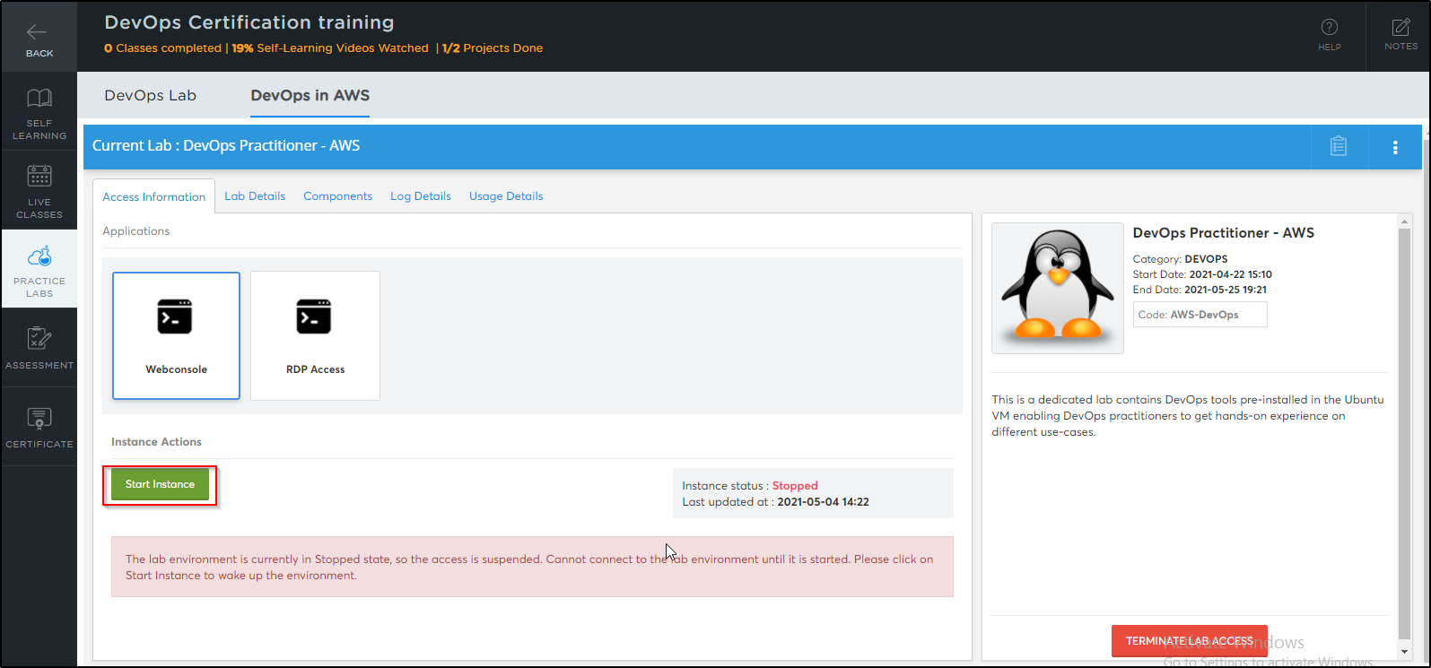

* Once the lab instance is started, click on the *Auth Url* as shown below:

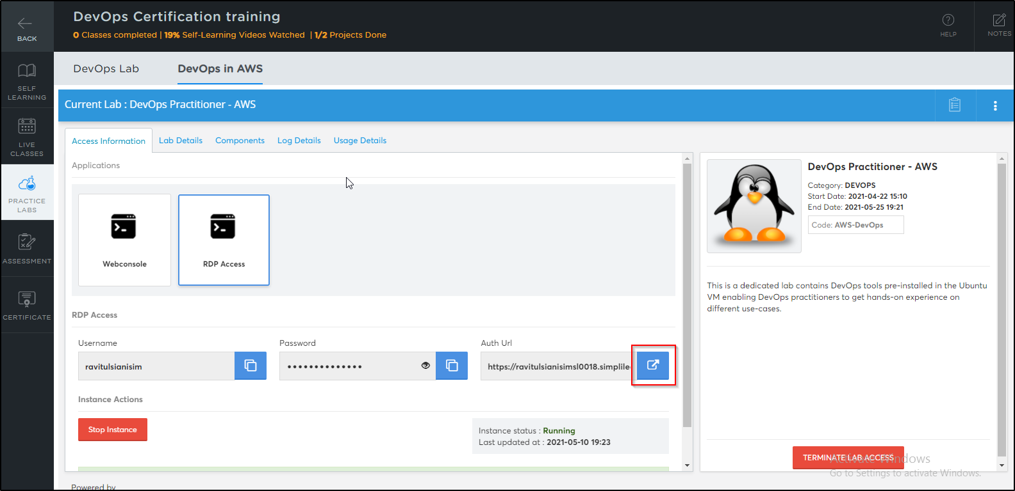

* You will be able to access IDEs and software which are present in labs

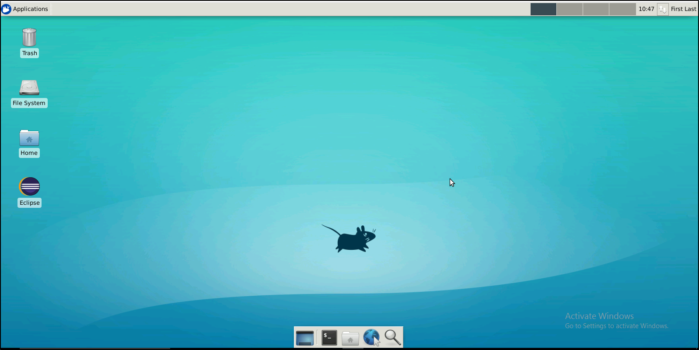

**Step 2:** Accessing the terminal lab through VM.

* Click on the Terminal only lab

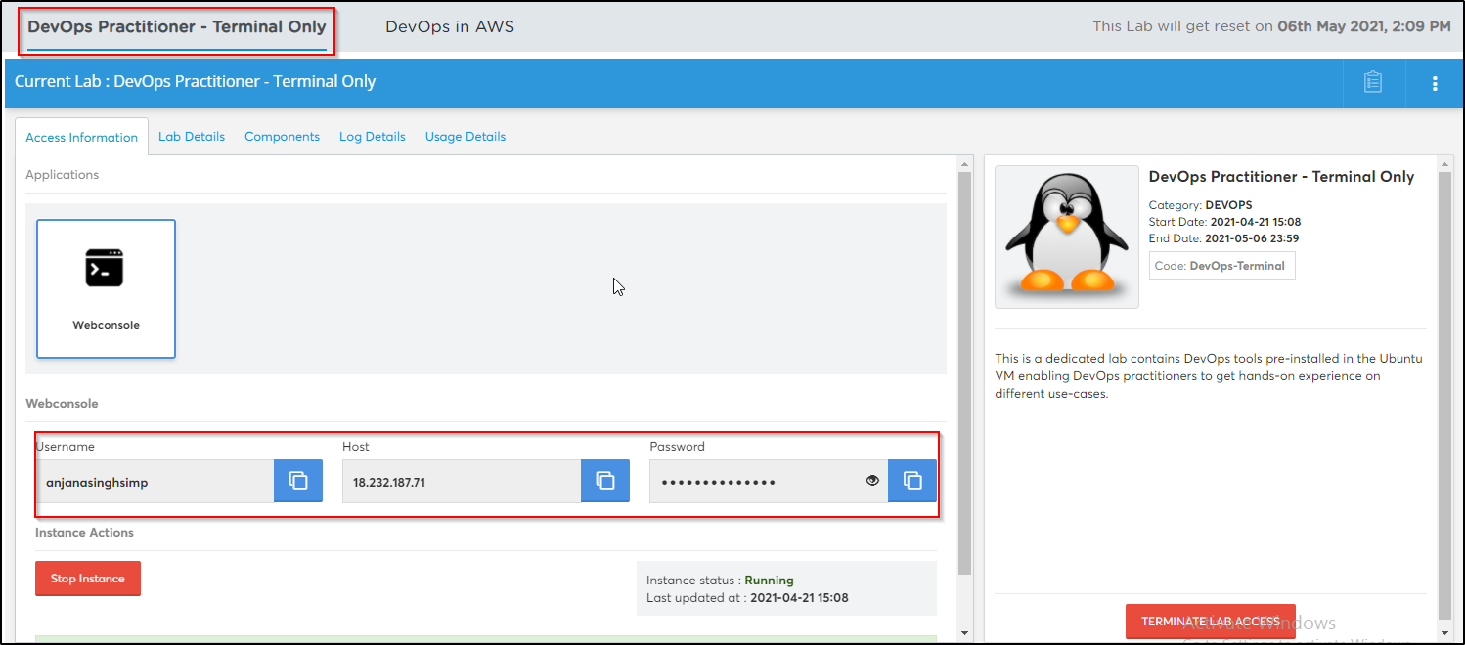

* Please launch the terminal only lab and save the credentials that are shown in the screenshot above
* Open the DevOps in AWS lab

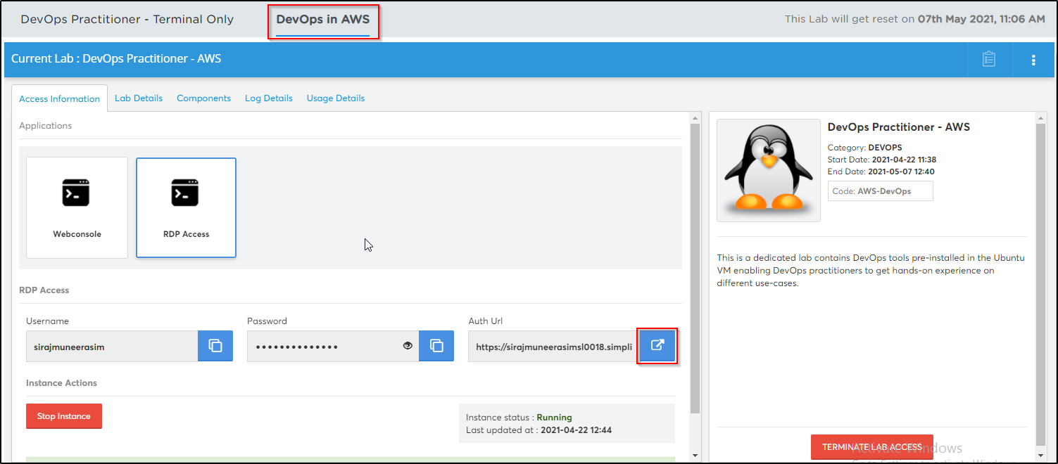

* Once the lab is launched, open the terminal
* Execute the below commands in the terminal in order to establish an ssh connection with the terminal only lab

***ssh username@ip -p 42006***

**Note:** The username, IP and password is the one that you saved initially in step 2.

* Type *yes* and enter the *password* when prompted.

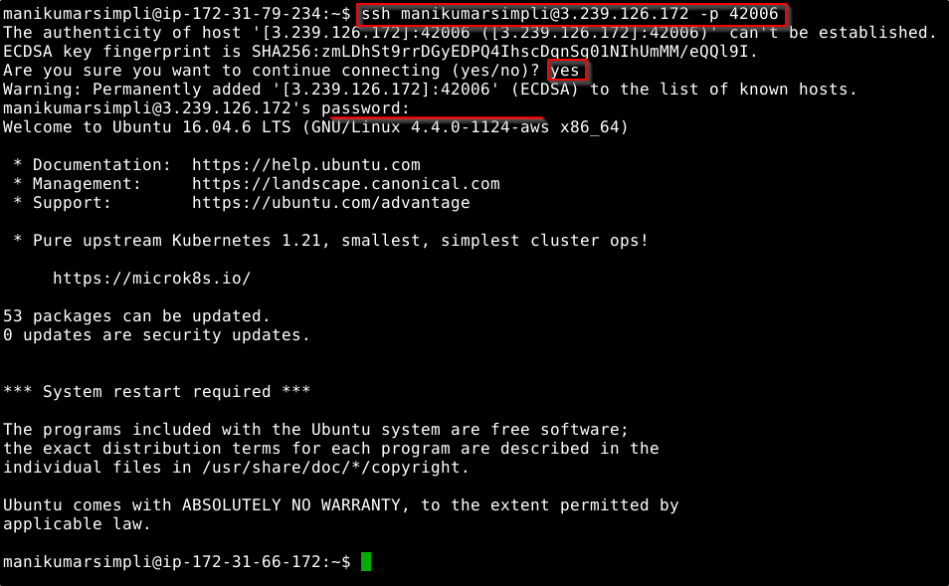

* The terminal only lab has the following tools pre-installed: git, java, maven, nodejs, docker, python, python3.

**Note:** Make sure you do not close the terminal that you used to establish the ssh connection. You might end the ssh connection to the terminal lab on closing the current terminal.

* In case you want to work on the DevOps AWS lab’s terminal, you will need to open a new terminal without closing the previous one

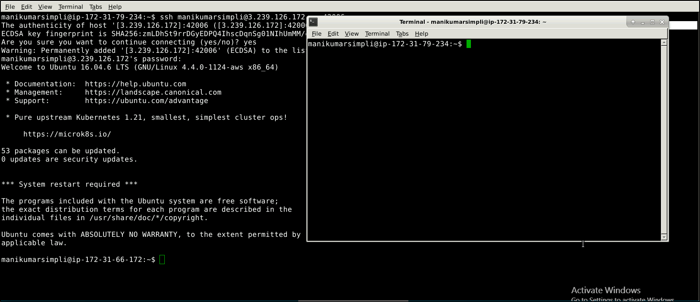

**Step 3:** Using different IDEs and software required

**Linux OS:**

* The virtual machines that we use in the labs are Linux OS
* To verify the version of the linux installation execute the below command in the terminal:

***lsb_release -a***

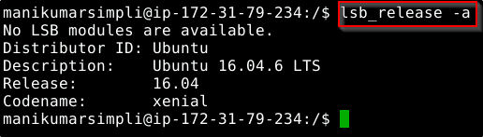

**Java:**

* Java 1.8 is already installed in the labs
* Open the terminal and type **java** **-version** to find whether Java is installed or not

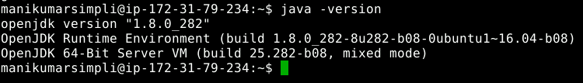

* If Java is not installed in your system, then use the following commands to install the same:

*sudo apt-get install openjdk-8-jdk*

*sudo apt-get install openjdk-8-jre*

**Git:**

* Git is already installed in the labs
* To check whether Git is installed properly or not run the following command:

***git --version***

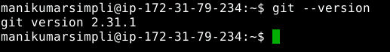

* If git is not installed in your system, then use the following commands to install the same:

*sudo apt-get update*

*sudo apt install git-all*

**Maven:**

* Maven is already installed in your practice labs
* You can use the following command to verify the installation:

***mvn -v***

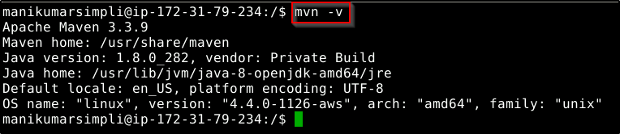

* In case Maven is not installed in your system, you can install it using the commands:

*sudo apt-get update*

*sudo apt-get install maven*

**Eclipse:**

* Double-click on the Eclipse icon
* Select a directory where you want to save your programs
* Select the **Use this as the default and do not ask again** checkbox and click on **Launch**

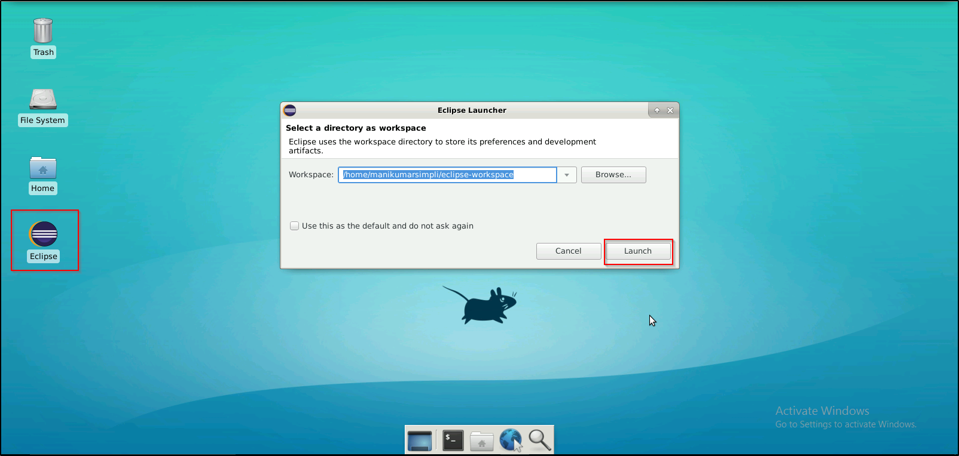

**Jenkins:**

* Jenkins (version 2.287) is already installed in your practice lab
* You will find it in the directory */usr/share*
* Use the following commands to navigate to the above-mentioned directory

***cd /usr/share***

***ls***

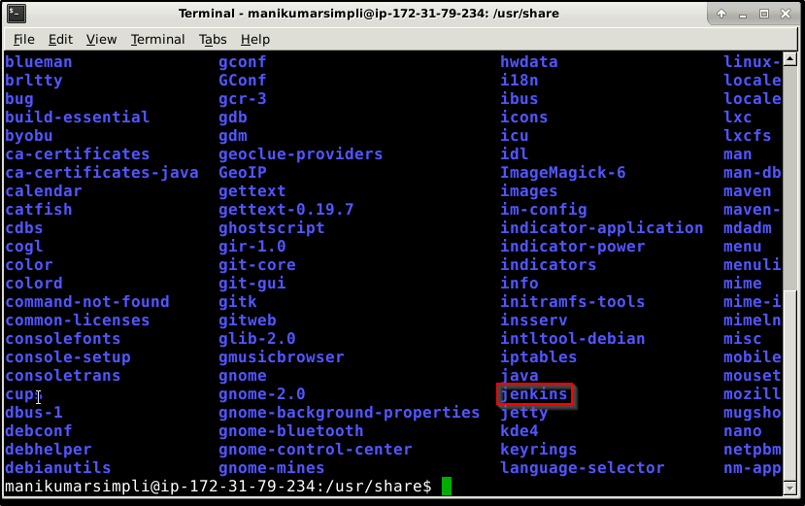

* To login to Jenkins dashboard navigate to ***localhost:8080*** from the browser in the lab
* In case Jenkins is not installed in your practice lab, you can install it using the commands:

*sudo apt update*

*sudo apt install jenkins*

**Node JS:**

* Node JS 14.16.0 version is installed in your practice labs
* To verify the installation, open the terminal and execute the command:

***node -v***

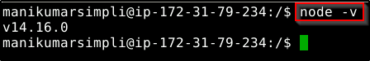

* The command mentioned above displays the Node JS version installed in your practice lab
* If Node JS is not installed in your practice lab, you can install it by using the commands:

*sudo apt-get update*

*sudo apt-get install nodejs*

**Docker:**

* Docker version 18.09.7 is already installed in your practice lab
* To verify the installation, open the terminal and execute the following:

***docker --version***

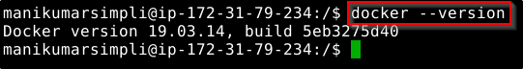

* In case Docker is not installed in your practice lab, you can install it following these steps:

1. Set up the Docker repository using the following commands:

*sudo apt-get update*

*sudo apt-get install apt-transport-https ca-certificates curl software-properties-common*

*curl -fsSL https://download.docker.com/linux/ubuntu/gpg | sudo apt-key add -*

*sudo add-apt-repository "deb [arch=amd64] https://download.docker.com/linux/ubuntu $(lsb_release -cs) stable"*

1. Install Docker using the command:

*sudo apt-get install docker-ce*

**Ansible:**

* Ansible 2.9.19 is already installed in your practice lab
* To verify the installation:

1. Open the command-line interface
2. Type the command:

***ansible --version***

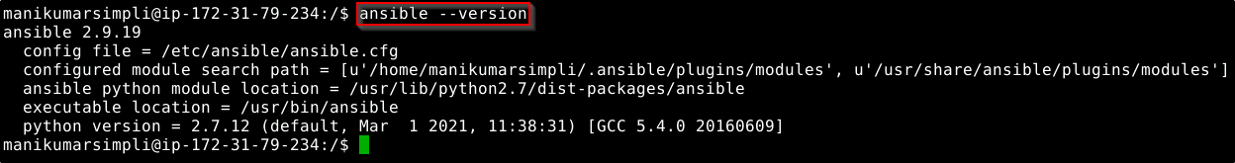

* If ansible is not installed in your practice lab, you can install it by using the commands:

*sudo apt-get install -f*

*sudo apt-get install software-properties-common*

*sudo apt-add-repository ppa:ansible/ansible*

*sudo apt-get update*

*sudo apt-get install ansible*

**Python:**

* Python is already installed in your practice lab
* To verify the installation, open the command-line interface and type the command:

***python --version***

***python3 --version***

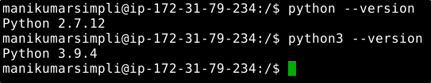

* If python is not installed in your practice lab, you can install it by using the commands:

*sudo apt-get update*

*sudo apt-get install python*

*sudo apt-get update*

*sudo apt-get install python3*